# Personal Portfolio Name:Zhifeng Liang Student No: N8976911

* 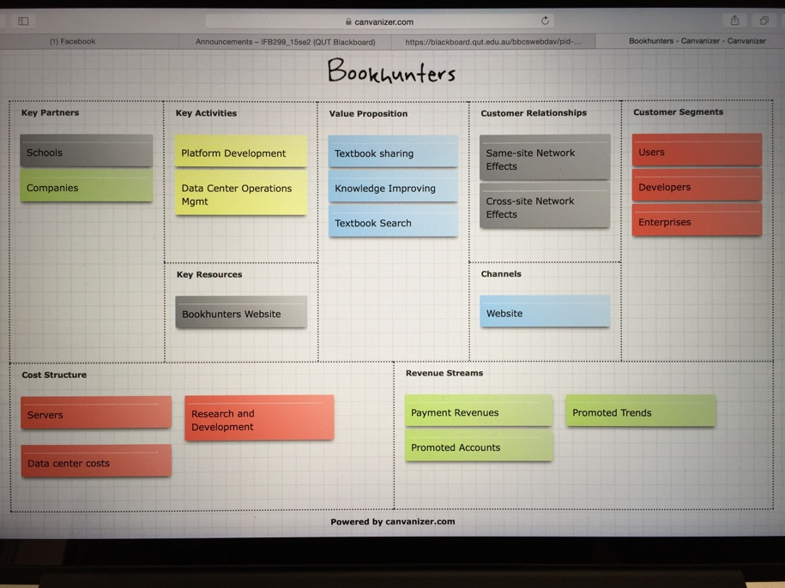**Business model for the project**: This is for the potential environment in which our product could be used. We can then use these business models to inform both the technical design of the system and the user experience. During the progress, I figured something out that can be go far in the future. Both the key partners and revenue streams were the first two good ideas that got into my mind. Meanwhile, I found some useful templets and examples to refer. Lastly, I combined all of the idea which was significant to make it by cavanizer.
* **Testing for the project**: I used the selenium ide for the testing. This is an automated testing tool. It can record your action on the website that you want to test. I cannot understand much about this application, however there is a tutorial on the blackboard that I can refer to. Then I watched the whole tutorial and also watched some tutorial videos on YouTube to make me easier to use it. After the tutorial, I tested it a few hours for it and there are some errors of our website: 1. Email confirmation does not work properly. It will send a verify link to the email but the link does not work. It has some bug of our ‘verification.php’ on line 28; 2. Users can use the account which it is without email confirmation to login. 3. A error shown up when users used an email address that they used before to register as same as username. The bug in ‘signUpScript.php’ one line 46. 4. A book can be upload if users did not fill any information up about the book. The selenium testing tool is quite useful to check errors or bugs on the website for us.
* **Feedback from potential users**: For the further expectation, I asked for some suggestions from my housemates and my friends. I let them to use our project which is the textbook sharing system and tried to get some comments on it. One of my friend said the main page can be better, and the sign up function did not work very well because they can not verify their email address; according to one of my housemate, he said the upload textbook page is too sample, also has some bugs which not very convenient; my another friend told me that it should be have some hot books on the main page to show up for the user, rather than finding the book list. After their user experiences, it is pretty helpful for us to improve our project such as interface, function, and so on. A perfect project always is based on users’ experiences, users’ requirements, and users’ feedback.
* **Prototyping**: for the coding part, as I am a IS student which I am not good at coding. Thus my CS teammates focus on the coding. However, there are so many coding that we have to do on this project. So I started learning some coding skills. I had done the password reset page and individual listing page for the project. The password reset page will have shown up the information which is ‘Your password has been reset, please do not tell your password to anyone!’. About the individual listing page is that show the picture of the textbook and introduction of the book, also have two bottom down the picture. The reason why I can finish the thing because my teammate, Toby taught me how to code some basic html coding step by step, and also sent a tutorial website and templet tome for studying. Based on the tutorial, I got some confidence to code something and learned some basic knowledge of html coding.
* **Peer review 1**: on workshop7, we had a demonstration to our client team, also they did the same thing to us as well. Both of our two team presented our project in some specific way which are interface, function, how the function works and so on. After that, I wrote some part of the peer review. One of my teammate had the record of the demonstration, so I watched the whole video and caught some features and some problems of their project, including their performance of presentation. I started to write the peer review immediately after the workshop. I wrote their performance based on the real thing happened on the workshop. At the meantime, I pointed some problems out which some of the bottom did not work well and some of the users’ stories have not finish, and then I provided some advises for these to help them solve the issue. I gave some expectations to our client team project too, to make the project better and better.

The reason why I will choose these five artefacts to be the example because these things is the best way that I can contribute for the team, everyone has their preferences and specialty. I just try to do something I can do and make sure these thing as better as possible for making a perfect team project.